HOTEL REVENUE ANALYSIS
MODULE 2

1. Objective
In this module our goal is to create tables like Duration_Details, Booking_Details, Month & Yearly Data (Pivot table) and Master Data table that will contain columns like ADR, RevPAR and Occupancy% which will be helpful in analyzing and visualizing the data.
2. Creation of Excel Tables:
2.1 Creation of Duration_Details Table:
- From Bookings Table, Create a table with the following columns: BookingID, DateID, RoomID, CustomerID, CheckInDate, CheckOutDate, NightsStayed, Total Price.
- Rename the table as Duration_Details.
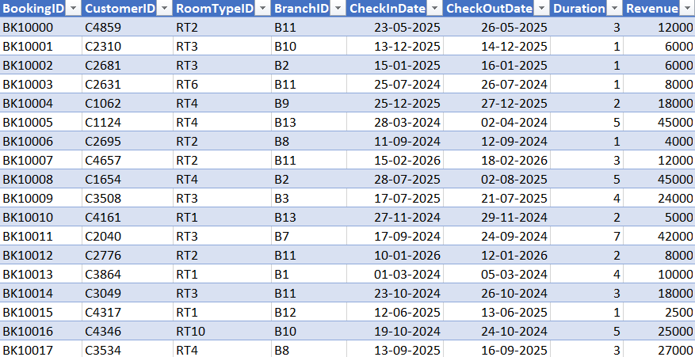
- After creating the table, select the table.
- Go to Data Tab $→$ Get & Transform Data $→$ From Table/Range.
2.1.1 Add Custom Column
- In Power Query Editor, go to Add Column →Custom Column.
- New Column Name: StayDate
- Formula:

if [CheckInDate] <> null and [CheckOutDate] <> null then
List.Dates(Date.From([CheckInDate]), Duration.Days([CheckOutDate] - [CheckInDate]), #duration(1,0,0,0))
else
null
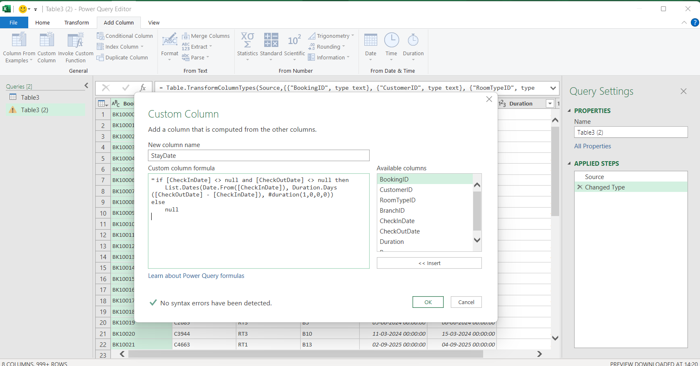
2.1.2 Expand Rows:
- Click the Expand arrows (two diverging arrows) next to the new StayDate column header and Select "Expand to New Rows".
2.1.3 Group By (Occupancy Count):
- Go to the Transform tab $→$Group By.
- Group By: StayDate.
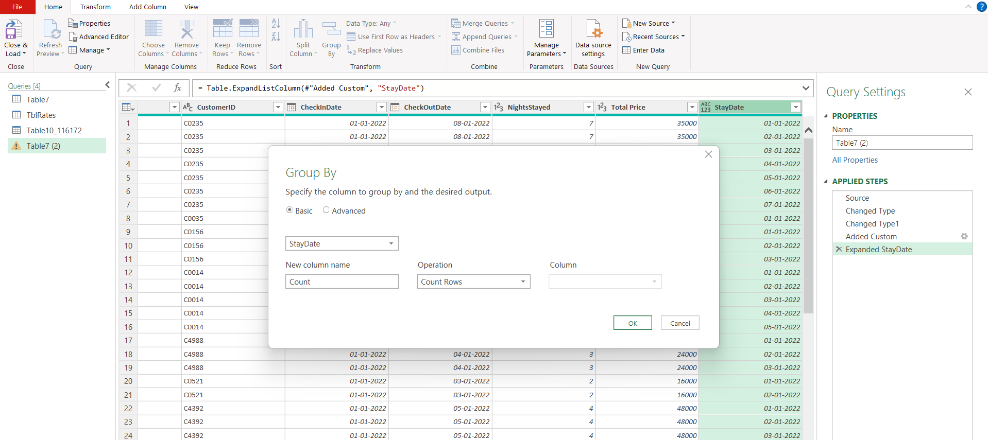
- New Column Name: Room Booked.
2.1.4 Load Data:
- Go to Home $→$Close & Load.
- Select New Worksheet.
- Rename the worksheet to "Booking_Details".
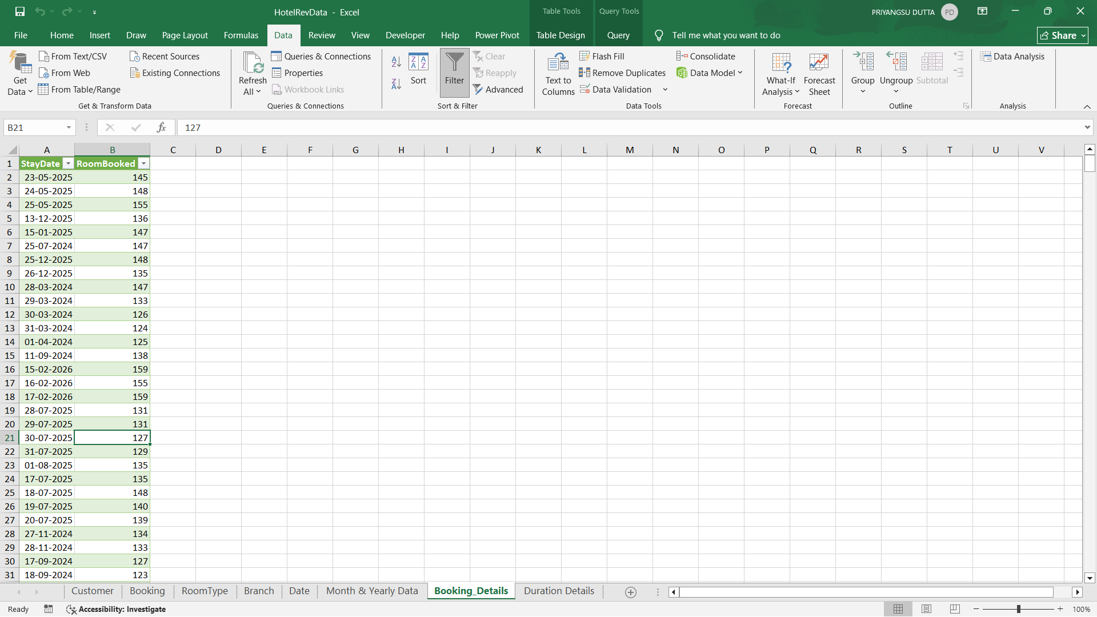

2.2 Creating "Month & Yearly Data" (Pivot Table)
This sheet is used for a quick summary view of room bookings aggregated by time.
- Insert Pivot:
  - Select the “Booking_Details” table and go to Insert $→$ PivotTable $→$New Worksheet.
- Configure Fields:
  - Rows: Drag Years, Months, and StayDate.
  - Values: Drag Room Booked (Ensure it is set to Sum).
- Formatting:
  - Rename the worksheet to "Month & Yearly Data".
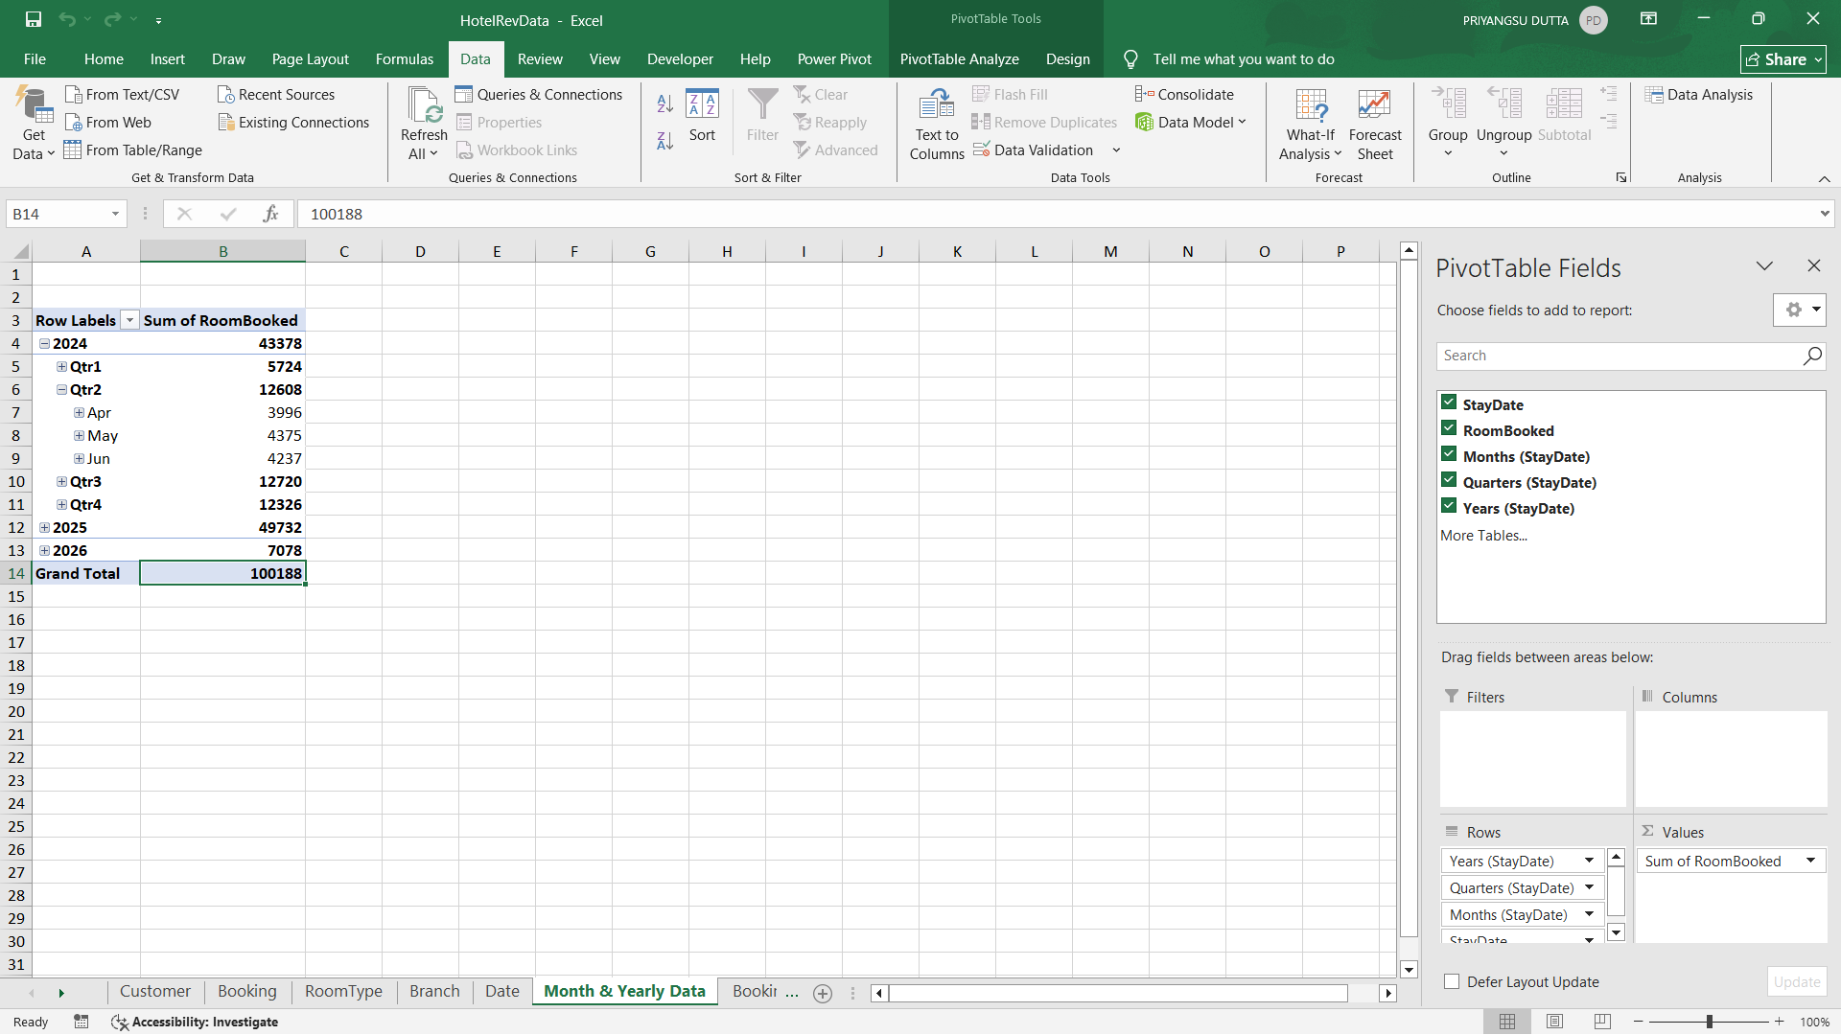

3. Power BI Data Modelling
3.1 Importing Data to Power BI
Open Power BI Desktop.
- Click on Home →Get Data →Excel Workbook and select the file containing your prepared tables (Booking_Details, Duration_Details).
- In the Navigator, select the following tables: Booking_Details, Duration_Details
- Click Load.
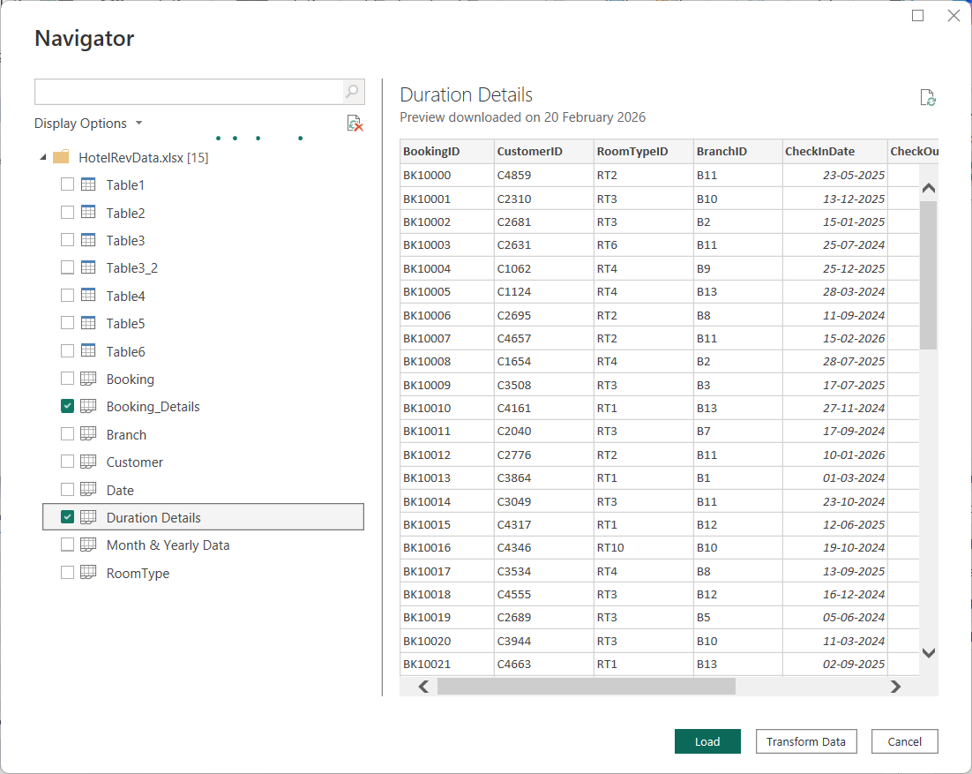
  - Enhancing the Booking_Details table

- Go to the Table View and select the Booking_Details table.
- Click the following columns by clicking New Column
- Formula:
- MonthStart = DATE(YEAR([StayDate]), MONTH([StayDate]), 1)
- MonthYear = FORMAT([StayDate], "MMM YYYY")
- Year = YEAR([StayDate])
- Month = FORMAT([StayDate], "MMMM")

- Season = SWITCH( TRUE(), MONTH([StayDate]) IN {12,1,2}, "Winter",
MONTH([StayDate]) IN {3,4,5}, "Spring",
MONTH([StayDate]) IN {6,7,8}, "Summer",
MONTH([StayDate]) IN {9,10,11}, "Autumn" )

- Weekday = FORMAT([StayDate], "dddd")
- WeekNum = WEEKNUM([StayDate])

- WeekStart = [StayDate] - WEEKDAY([StayDate], 2) + 1

- YearWeek = FORMAT([StayDate], "YYYY") & "-W" & WEEKNUM([StayDate])
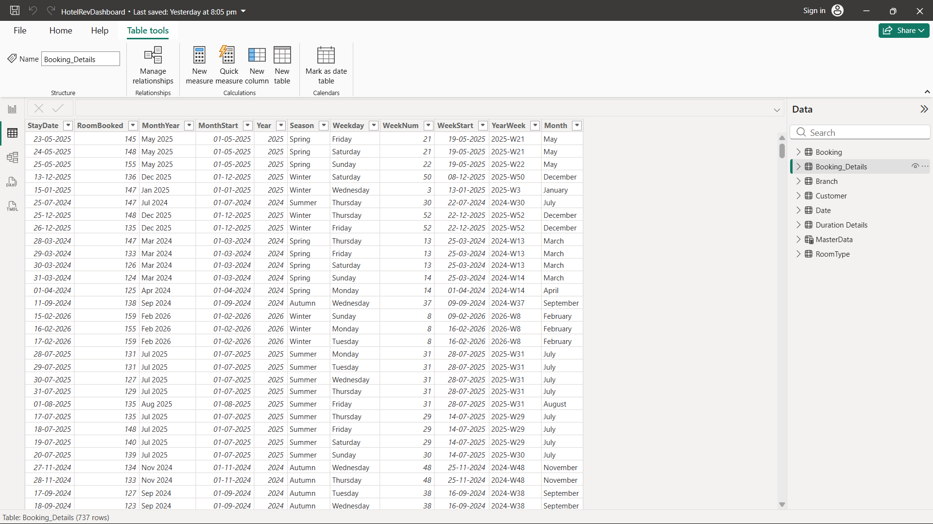

  - Creating the MasterData Table
3.3.1 Go to the Modeling tab $→$ click New Table and paste the following DAX formula and press the green tick:
MasterData =
VAR CalendarTable =
ADDCOLUMNS (
CALENDAR (DATE(2024,2,1), DATE(2026,2,1)),
"MonthStart", EOMONTH([Date], -1) + 1,
"Month", FORMAT(EOMONTH([Date], -1) + 1, "dd-mmm-yy"),
"DayCount", DAY(EOMONTH([Date], 0)),
"RoomAvailableCount", DAY(EOMONTH([Date], 0)) * 300
)
RETURN
ADDCOLUMNS (
SUMMARIZE (
CalendarTable,
[MonthStart], [Month], [DayCount], [RoomAvailableCount]
),
"RoomSoldCount",
CALCULATE (
SUM (Booking_Details[RoomBooked]),
TREATAS ( { [MonthStart] }, Booking_Details[MonthStart] )
),
"Occupancy %",
DIVIDE (
CALCULATE (
SUM (Booking_Details[RoomBooked]),
TREATAS ( { [MonthStart] }, Booking_Details[MonthStart] )
),
[RoomAvailableCount],
0
)
)

- Change the format of occupancy to percentage

    - Right-click on the MasterData table and select New Column
Formula:
TotalRevenue =
CALCULATE(
SUM(Booking[Revenue]),
FILTER(Booking, Booking[MonthStart] = MasterData[MonthStart])
)

Total Revenue represents the gross income generated strictly from room bookings for the selected month.

    - Again, Click on New Column
Formula:

ADR = DIVIDE(
[TotalRevenue],
MasterData[RoomSoldCount]
)

Average Daily Rate (ADR) represents the average price paid for an occupied room.

    - Click on New Column
Formula:
RevPAR = [ADR] * MasterData[Occupancy %]
RevPar represents the revenue generated per room in the hotel, regardless of whether it was occupied or empty.
- Change the format of both ADR and RevPAR to currency (₹ Hindi)
    - Create a measure name MADR by clicking New Measure and pasting this formula:
MADR =
DIVIDE(
SUM(Booking[Revenue]),
SUM(Booking[RoomNightSold])
)

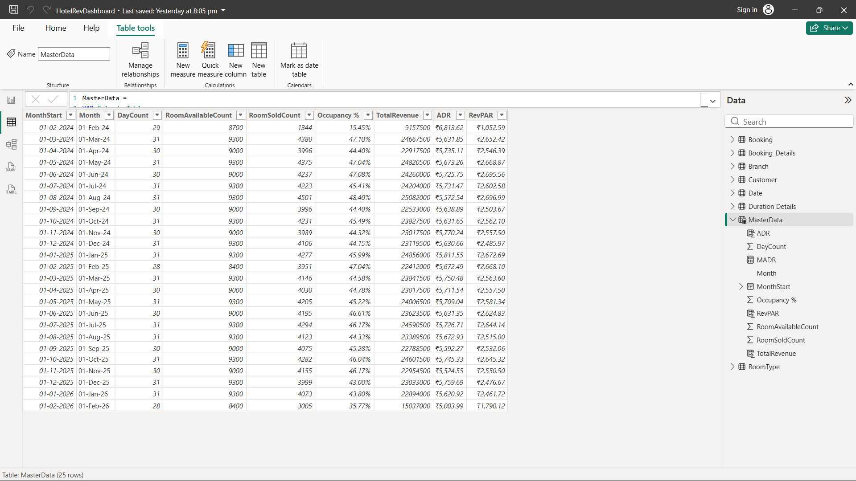
  - Creating the Tbl_Calculation Table
This is the consolidated table used for final calculations using the derived data.
3.4.1 Create Sheet: Name it "Tbl_Calculation".
3.4.2 Columns & Formulas:
- StayDate and Room Booked Count : Copy from Booking_Details Table.
- In Power BI, create the columns with New column option using the formulas:
- TotalRevenue =
CALCULATE(
SUM(Tbl_Bookings[DayRevenue]),
FILTER(Tbl_Bookings, Tbl_Bookings[StayDate] = Tbl_Calculation[StayDate])
)
- TotalRooms = 300
- Occupancy % = DIVIDE([RoomBooked], [TotalRooms]) * 100
- ADR = DIVIDE([TotalRevenue], [RoomBooked])
- RevPAR = DIVIDE([TotalRevenue], [TotalRooms])
- Season = SWITCH(
TRUE(),
MONTH([StayDate]) IN {12, 1, 2}, "Winter",
MONTH([StayDate]) IN {3, 4, 5}, "Spring",
MONTH([StayDate]) IN {6, 7, 8}, "Summer",
MONTH([StayDate]) IN {9, 10, 11}, "Autumn"
)
- Weekday = FORMAT([StayDate], "dddd")
- Week = WEEKNUM([StayDate])
- MonthStart = DATE(YEAR([StayDate]), MONTH([StayDate]), 1)
- Month = FORMAT([MonthStart], "MMMM")
- Quarter =
"Q" & FORMAT([StayDate], "Q") & " " & FORMAT([MonthStart], "YYYY")

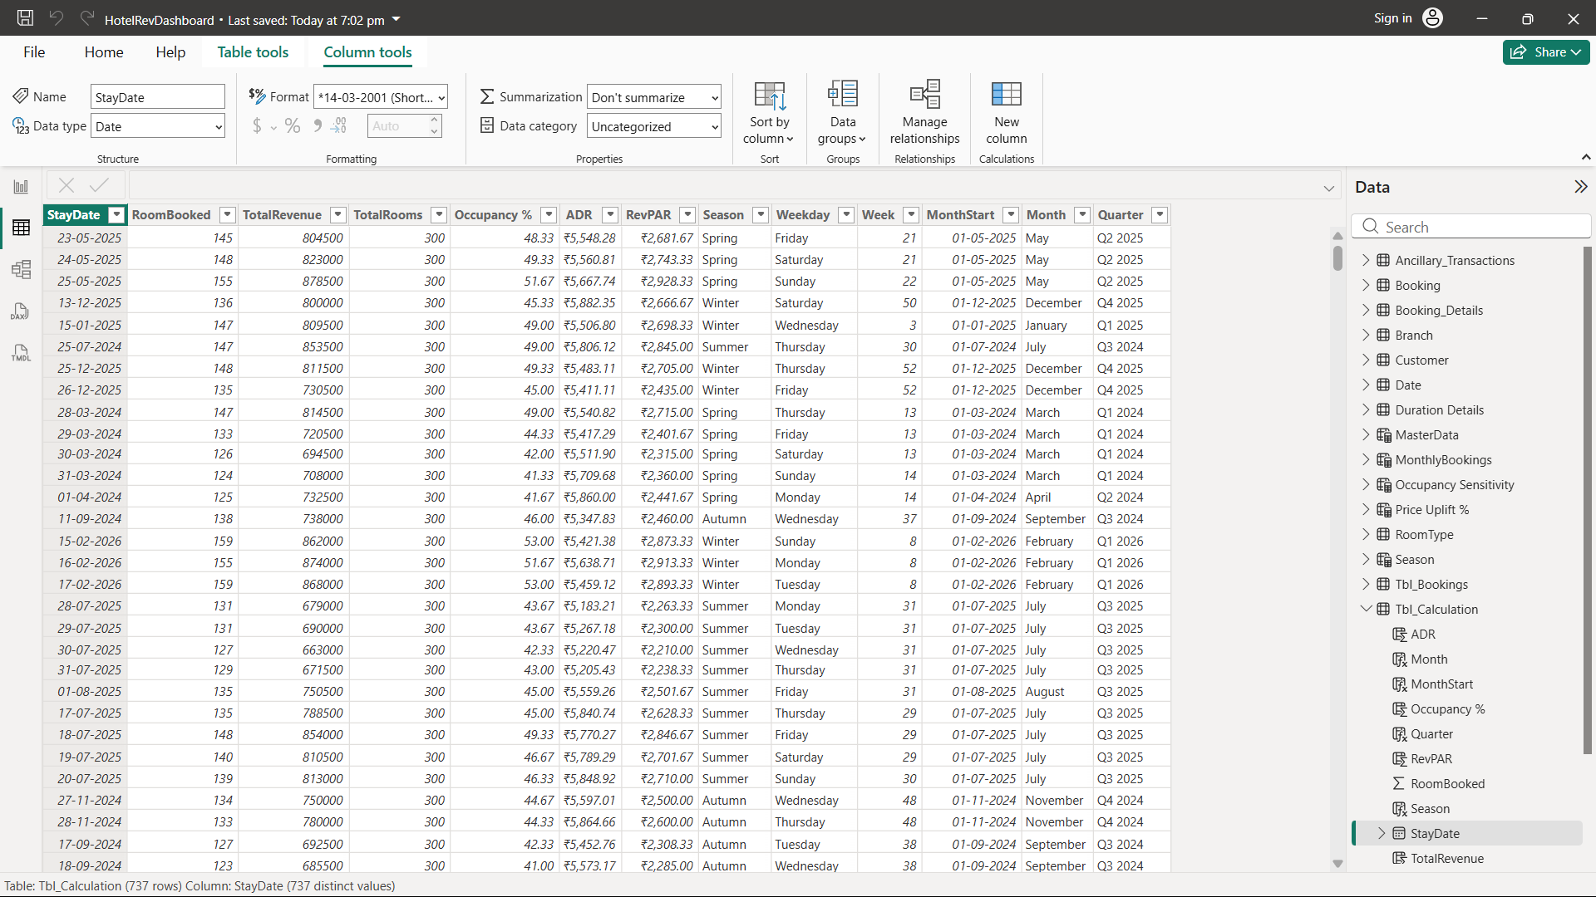
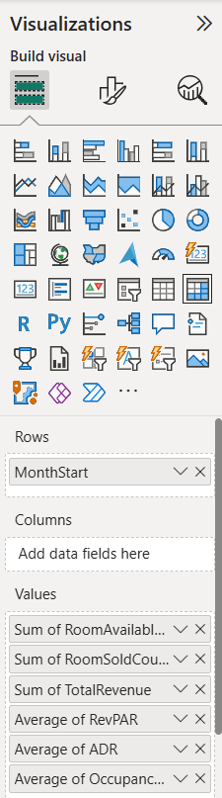
- PowerBI Visuals:
Visual 1: Summary Table (From Master Data)
- Select Visual: Click the Matrix table in the visuals.
- Add Rows: Drag the following field in this order:
  - MonthStart
- Add Columns: Drag the following fields in this order:
  - RoomAvailableCount (Set to Sum)
  - RoomSoldCount (Set to Sum)
  - TotalRevenue (Set to Sum)
  - ADR (Set to Average)
  - Occupancy % (Set to Average)
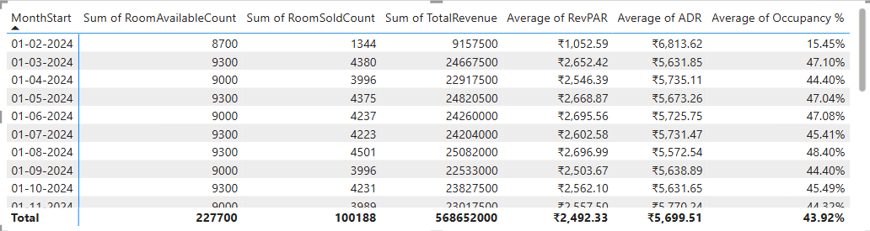

Visual 2: Line Chart
- Select Visual: Click the Line Chart icon in visuals.
- X-Axis: Drag MonthStart from the MasterData table.
- Y-Axis: Drag the following three fields:
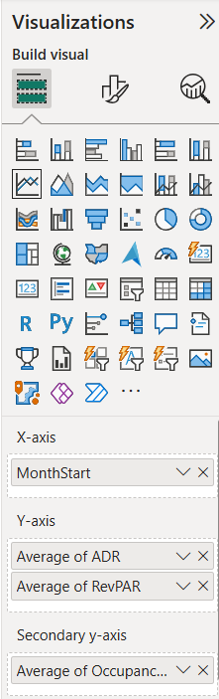
  - ADR (Set to Average)
  - RevPAR (Set to Average)
- Secondary Y-Axis: Occupancy % (Set to Average)

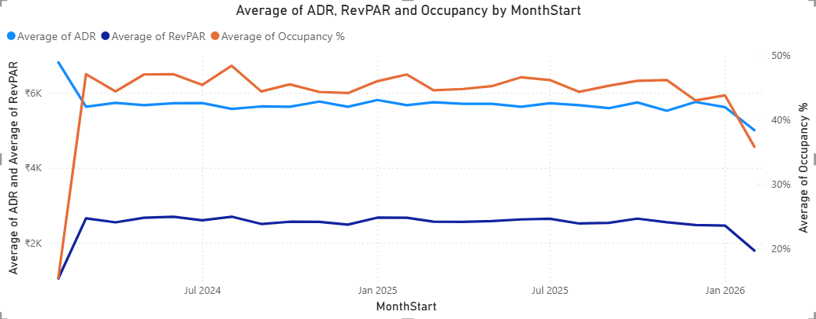

Visual 3: KPI Cards

- Select Visual: Click the Card visual icon (looks like 123).
- Card 1 (ADR):
  - Drag ADR from Tbl_Calculation (or your Measure table) to Fields.
  - Ensure aggregation is set to Average (Click dropdown arrow > Average).
  - Format: General > Title > "Average of ADR". Callout Value > Display units > Auto (shows ₹10.00K).
- Card 2 (Occupancy):
  - Copy/Paste Card 1.
  - Replace field with Occupancy%. Set aggregation to Average.
- Card 3 (RevPAR):
  - Copy/Paste Card 1.
  - Replace field with RevPAR. Set aggregation to Average.
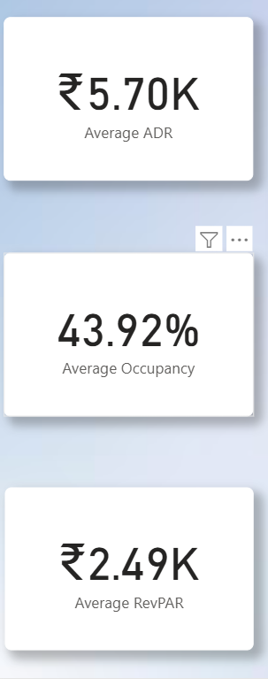

Build more visuals in same way and create the following dashboard pages.
Dashboard:
